PHASE 7 OF 8
Project Documentation Phase
Deployment & Final Report

Project | Platform | Team
Auto Ticket Classification using Flow Designer | ServiceNow (Flow Designer) | SAMRIN HASRAA S  SALMA FARHANA M  SAJITHA FATHIMA S K  FATHIMA M

1. Abstract
This project automates ticket classification for a school IT helpdesk using ServiceNow Flow Designer. When a student or teacher raises a ticket, a flow inspects the Short Description, assigns the correct Category and Subcategory, and emails the caller a confirmation – without code and without manual work from IT staff.

2. Project Summary
Item | Details
Title | Auto Ticket Classification using Flow Designer
Domain | IT Service Management (ITSM) / Education
Platform | ServiceNow Personal Developer Instance
Custom table | Incident Workflow (u_incident_workflow)
Automation | Flow *Auto Classify School IT Tickets* (trigger: record created, Category is empty)
Notification | Email to caller: *Your Request for the issue has been submitted*
Packaging | Project Update Set (Global) exported as XML

3. Deployment – Update Set

Make the Update Set Complete
- Go to All → Local Update Sets (under *System Update Sets*).
- Open Project Update Set.
- Change State from *In progress* to Complete and Update the form.
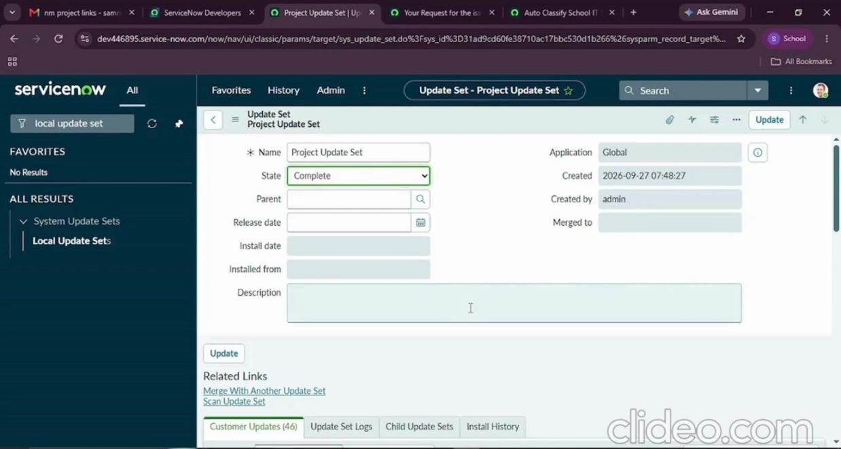
Figure 7.1 – Update Set marked Complete

Export to XML
- Under *Related Links* click Export to XML.
- The XML file (sys_remote_update_set_…xml) is downloaded. It is included in the repository under update_set/.
- Share the file by mail or messaging app to move the solution to another instance.
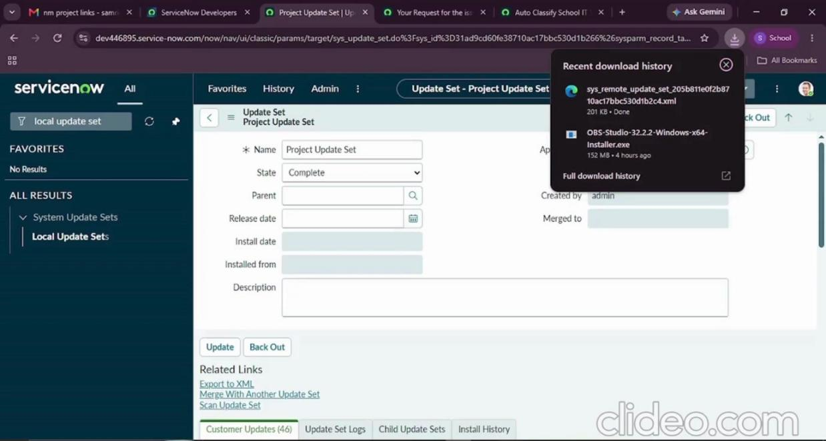
Figure 7.2 – Update Set XML downloaded

4. User Guide (Students / Teachers)
- Open the *Incident Workflow* table and click New.
- Choose your name in Caller.
- Write a short description of the problem, e.g. *Wi-Fi not working in library*, *Projector not turning on*, *Forgot password*, *Slow Computer*.
- Click Submit. Category and Subcategory are filled automatically.
- Check your mailbox for the confirmation email.

5. Administrator Guide

Add a new issue type (example: Printer)
- Add a Category choice (or reuse one) and a Subcategory choice such as Printer Not Working.
- On the Subcategory choice record, set its Dependent value to the matching Category.
- In Flow Designer add a new Else If with *Short description contains Printer*.
- Add Update Record to set the Category and Subcategory.
- Save, re-activate the flow and test.

Add more keywords to an existing rule
Open the condition, click Add another condition set (OR) and add another *Short description contains …* row (for example WiFi, Login, Hanging).

Troubleshooting
Problem | Likely cause | Fix
Category not filled | Flow inactive, or no keyword matched | Activate the flow; check the description and condition values
Category not filled even with keyword | Typo in the condition value | Correct the *contains* value and retest
Email not received | Caller has no email, or outbound mail not configured on PDI | Check caller profile; view the record in System Logs → Emails
Subcategory list empty | Dependent value not set | Set the Dependent value on each Subcategory choice

6. Results and Benefits
- Tickets are classified instantly at creation.
- Manual triage effort for IT agents is removed.
- Data is consistent thanks to choice lists and dependent fields.
- Callers receive immediate acknowledgement.
- Maintenance needs only Flow Designer – no scripting.

7. Limitations
- Keyword matching depends on the wording of the Short Description.
- Only four issue types are covered in this version.
- Tickets without a matching keyword are not classified.

8. Future Enhancements
- Auto-assign the Assigned Group / Assigned to based on Category.
- SLA tracking and escalation.
- Predictive Intelligence for smarter classification.
- Priority calculation and notifications to agents.
- More keywords and multi-language support.

9. Conclusion
The Auto Ticket Classification using Flow Designer project delivers an end-to-end, no-code automation for a school IT helpdesk. Through requirement analysis, backend configuration and Flow Designer automation, tickets are classified automatically from the short description. Dependent choice fields keep data accurate, and automated emails improve communication. Testing confirmed that the solution works reliably and protects data through access controls. The design suits small and medium environments such as schools and can be extended with assignment automation, SLA tracking or predictive intelligence.

10. References
- ServiceNow Docs – Flow Designer
- ServiceNow Docs – Tables and Columns, Dependent Choice Lists
- ServiceNow Docs – Update Sets
- SmartBridge project document: Auto Ticket Classification using Flow Designer

